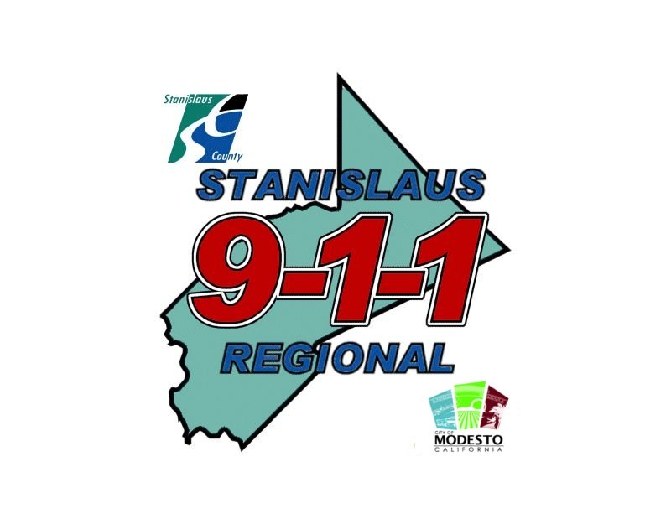
The professional connection between the community and public safety

________________________________________________________________________

You will need to supply Stanislaus Regional 9-1-1 with
ORIGINAL, OFFICIAL or CERTIFIED copies of the following documents
(as they apply to you specifically). Copies of these items will be submitted along with the rest of the documents for the background investigation:

- BIRTH CERTIFICATE
- SOCIAL SECURITY CARD
- NATURALIZATION CERTIFICATE or RESIDENT ALIEN CARD
- PROOF OF SELECTIVE SERVICE REGISTRATION (men born after March 28, 1957 and
Before January 1, 1960 were not required to register with the Selective Service).
- IF YOU WERE IN THE MILITARY, A PHOTOCOPY OF YOUR DD214 LONG FORM
(DISCHARGE))
- HIGH SCHOOL DIPLOMA or GED EQUIVALENCE
- COLLEGE DEGREE
- MARRIAGE CERTIFICATE(S)
- ANY FINAL DECREES OF DIVORCE(S)
- PROOF OF AUTOMOBILE LIABILITY INSURANCE
- CALIFORNIA DRIVERS’ LICENSE for identification purposes only
- CIVIL JUDGEMENTS where you were the plaintiff or defendant in the past seven years
- COPIES OF TRAFFIC COLLISION REPORTS, IN WHICH YOU WERE NAMED AS DRIVER
- COPIES OF POLICE REPORTS, IN WHICH YOU WERE ARRESTED
- P.O.S.T. CERTIFICATE(S)
- PHOTOCOPIES OF PROFESSIONAL CERTIFICATES, AWARDS, TRAINING CERTIFICATES OR
RECOGNITIONS, WHICH YOU WOULD LIKE CONSIDERED

Please include this document with your records

