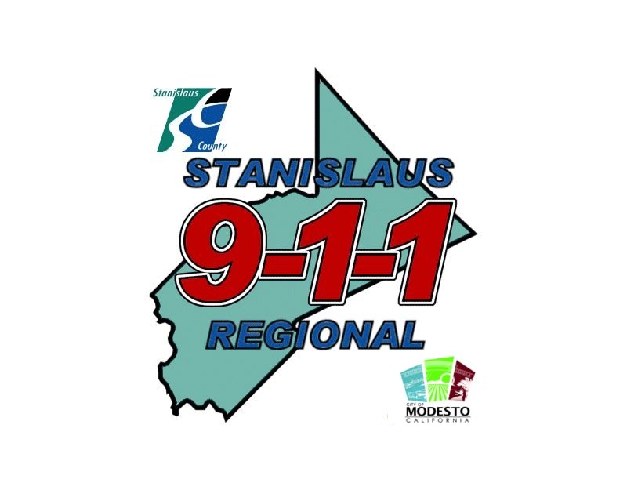

YOU WILL NEED TO
HAVE THIS WAIVER OFFICIALLY
NOTARIZED FOR
THE BACKGROUND INVESTIGATOR.

(FOR A NOTARY CHECK YOUR PHONE BOOK YELLOW PAGES FOR NOTARIES)

The professional connection between the community and public safety

________________________________________________________________________

AUTHORIZATION TO RELEASE INFORMATION
(PUBLIC SAFETY ALL TAKER/DISPATCHER)

TO WHOM IT MAY CONCERN:

I, ___________________________________________, am an applicant for the position of Emergency
(Enter your full name)
Dispatcher with Stanislaus Regional 9-1-1. Under California law, (Code of Regulations Section 1018[c], enacted pursuant to Penal Code Section 13510[c], my prospective employer is required to conduct an investigation into my personal, medical and psychological fitness to serve in this capacity.

I hereby direct you, your organization, its Custodian of Records, and/or persons in your employ to release any and all information which you may have concerning me, including information which may be of a confidential, privileged and/or derogatory nature, including, but not limited to: employment information, official employment documents, employment performance data, character reference information, educational records and transcripts (pursuant to Public Law 93-380), medical, surgical, psychological and dental records if I am offered employment with this agency (pursuant to the Medical Information Act, Civil Code Section 56 et seq. and 29 C.R.F. 1630), credit and financial information (pursuant to Penal Code Section 13300 [b][10]), and/or any other information which you may possess. And I exonerate, release and discharge you, your organization, its officers, agents, and assigns, from any liability or damages, whether in law or in equity, now and in the future, for furnishing the information requested by the bearer of this authorization form.

Because the background investigation is mandated by law, your responses enjoy absolute privilege under California Civil Code Section 47.

I have specifically and permanently waived any rights I may have to review or inspect any and all information developed in the investigation so your responses will be completely confidential pursuant to Labor Code Section 1198.5. You may retain this form for your files.

CERTIFICATION: I certify that I have read this authorization form, understand its meaning and purpose, and may receive a copy of it, if I wish. I may revoke this authorization at any time by delivering, in writing, such revocation to you/your organization.

This release expires 120 days from the date of signature.

______________________________________________
Print Name

______________________________________________ Date: __________________________
Signature

NOTARIZATION REQUIRED

