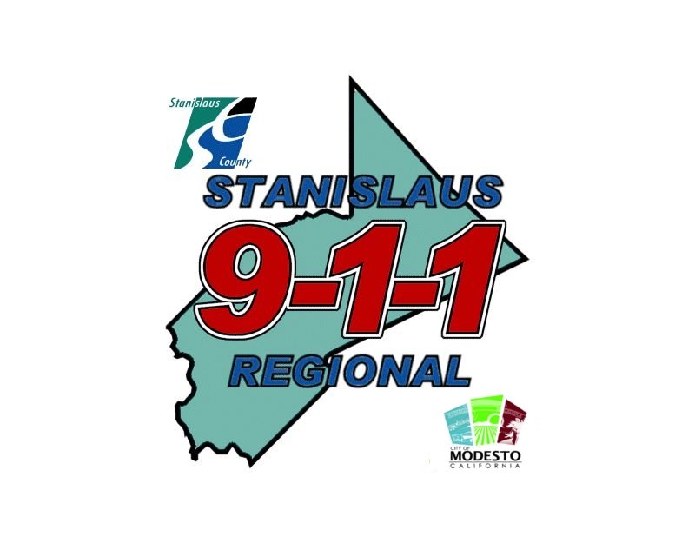
The professional connection between the community and public safety

________________________________________________________________________

Re: Authorization to complete Pre-Employment Background Investigation

A pre-employment background investigation is not intended to be an intimidating experience or any unwarranted invasion into your privacy. Your background investigator will contact persons who know you, including present and/or former employers, and will examine official documents and records concerning you to assure that you have been honest in your application in order to fulfill the legal mandates imposed by the courts and the legislature.

I _________________________________ realize the Stanislaus County Sheriff’s Department or
Name
Stanislaus Regional 9-1-1 or Gold Shield Investigations or City of Modesto Police Department, in order to conduct a background investigation on myself for the position of Emergency Call Taker, the investigator must be able to obtain confidential information from persons who have information regarding my work record, reputation, education, medical, physical and mental history. THIS IS NOT A JOB OFFER. The purpose of the pre-employment background investigation is to verify that the information you have submitted and any statements you have made concerning your qualifications are true.

I further realize the Stanislaus County Sheriff’s Department or Stanislaus Regional 9-1-1 or Gold Shield Investigations or City of Modesto Police Department investigators obligation to insure any and all persons that any information they release regarding me will be kept in the strictest of confidence.

I understand that I will not be allowed access to any information obtained by the investigators conducting the background investigation.

This is a time sensitive process, and I understand it is necessary for me to complete and return the background papers which I have been given within ten (10) days. Failure to return these background documents in the required time frame will result in my application being withdrawn for further consideration.

CERTIFICATION: I certify that I have given my permission for Stanislaus Regional 9-1-1/Modesto Police Department/Stanislaus County Sheriff’s Department to conduct a pre-employment background investigation. I understand that the pre-employment background IS NOT A JOB OFFER.

I have read and understand the above information

_________________________
Signature of Applicant Date

______________________________ _________________________
Witness (9-1-1 Staff Member) Date

