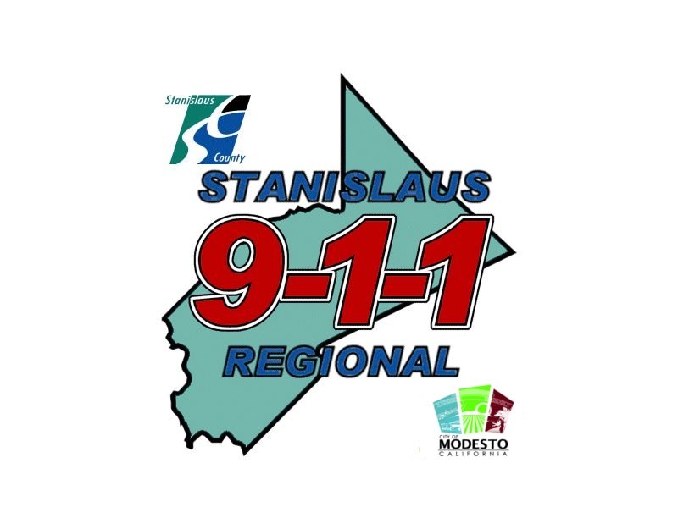
Stanislaus Regional 9-1-1
Background Investigations Pre-Screening Tool
Applicant’s Full Name:
Applicant’s Drivers License Number: State:
The pre-screening tool is an objective way for the Department to proceed with the most qualified candidates.
- Have you ever been arrested before? Yes No
Explain:
- As an adult have you ever run (Fled) from a Police Officer or Law Enforcement Official? Yes No
Explain:
- Have you used any illegal drugs within the last 3 years?
Yes No
- If you have used an illegal drug within the last 3 years, what was it?

- How many moving violations have you had within the last 3 years?

- How many traffic accidents in which you were at fault have you had in the last 3 years?

- Have you ever falsified a timecard or time worked?
Yes No
Explain:
- Do you currently have one or more accounts delinquent or late and turned over to a collection agency? Yes No
What are you doing to correct this situation?
- Have you ever filed for Bankruptcy?
Yes No
Explain:
- What is your highest level of education?

- How many college units/credits do you have and what is your GPA?
UNITS/CREDITS GPA
- Have you ever been fired, terminated or asked to resign from a place of employment?
Yes No
Explain:
- Have you ever violated a work policy that if caught you would have been fired?
Yes No
Explain:
- Have you ever had a Restraining Order filed against you?
Yes No
Explain:
- Have you ever been evicted from your place of residence?
Yes No
Explain:
- Have you paid for the services of a prostitute (male or female)?
Yes No
Explain:
- Have you ever hit, struck, slapped, kicked, pushed, or grabbed your spouse, domestic partner, girlfriend, or boyfriend in anger or while involved in an argument at home or in public?
Yes No
Explain:
- Have you ever mistreated an elderly parent, grandparent, aunt, uncle, or any other elderly person in your trust?
Yes No
Explain:
- Have you ever been accused of or questioned about child abuse, child neglect or child molestation?
Yes No
Explain:
- Have you ever belonged to or worked with any group or gang, which engages in unlawful or terrorist activities?
Yes No
Explain:

