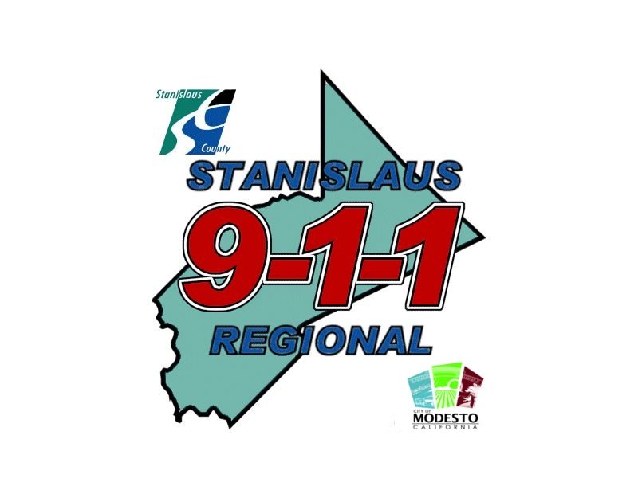
STANISLAUS REGIONAL 9-1-1

SUBSTANCE ABUSE QUESTIONNAIRE
APPLICANT NAME: DATE:

Last Updated 10/24/2013
ANY ACTIVITY INVOLVING THE USE OF ILLEGAL DRUGS OR NARCOTICS

If you respond “YES” to any question, you MUST provide an explanation on the facing page. Fill in all boxes provided. If the incident has occurred more than once, make sure you explain all occurrences. Start with the most recent. Failing to follow instructions or untruthful answers will be cause for disqualification.

 | Have you ever used, tried, tasted, ingested, inhaled, injected, sniffed, smoked, swallowed, pretended to use, simulated use, attempted to use, tested, thought you were using, or experimented with the following?
 | NAME OF DRUG, NARCOTIC OR CHEMICAL (formal or street name) |  | NO | YES | Age when first used | Month & Year last used | Age when last used
 | A. | MARIJUANA (grass, weed, pot, doobie, mota, joint, reefer, ganja)
 | B. | HASHISH (hash)
 | C. | CRACK COCAINE (crack, rock, smoked cocaine)
 | D. | COCAINE (coke, snow, candy, snowbird)
 | E. | SPEED
 | F. | METH-AMPHETAMINE (meth, crystal, crank)
 | G. | LSD (Acid, sugar cube, tabs, white lightning, microdot)
 | H. | PCP (Angel dust, sherm, killer weed, lovely, whack, love boat)
 | I. | HEROIN (smack, brown sugar, junk, black tar, H, mud)
 | J. | OPIUM (Dover’s powder)
 | K. | MUSHROOMS, PEYOTE (Buttons, cactus, shrooms, magic)
 | L. | BARBITURATES (Downers, reds, red devils, pink ladies)
 | M. | AMPHETAMINES (Uppers, cross tops, whites, bennies)
 | N. | MORPHINE
 | O. | RAVE DRUGS (Rohypnol, ruffles, rocha, liquid X, love drug)
 | P. | ECSTASY (Designer drugs, K-hole, E,TC, GHB, love)
 | Q. | AMYL NITRITE (Rush, locker room, climax, snappers)
 | R. | INJECTED STEROIDS
 | S. | ORAL STEROIDS
 | T. | GLUE, PAINT THINNER, PAINT, SOLVENTS, AEROSOLS

 | Have you ever used, tried, tasted, ingested, inhaled, injected, sniffed, smoked, swallowed, pretended to use, simulated use, attempted to use, tested, thought you were using, or experimented with any other drug or narcotic not listed above? Yes No If yes, provide the following information below.
 | NAME OF DRUG, NARCOTIC OR CHEMICAL (formal or street name) |  | Age when first used | Month & year last used | Age when last used
 | A.
 | B.
 | C.
 | D.

Indicate Question Number | Explain circumstances (Any omissions or falsifications of information provided in this questionnaire, will result in the elimination of the applicant from the hiring process. All information will be verified by polygraph examination.) | What was your age the first time this occurred | What was your age the last time this occurred | Indicate month & year last time this occurred

Question |  |  | NO |  |  | YES
 | To the best of your recollection, have you been intoxicated, other than at home, during the last twelve (12) months solely through the consumption of alcoholic beverages?
 | Has your alcohol use ever affected your work (i.e. calling in sick, tardy, performance, etc.)?
 | In the last 3 years, have you been warned by an employer about your drinking or drug habits and their impact on your performance?
 | Have you ever worked under the influence of illegal drug, narcotic or controlled substance?
 | Have you ever had illegal drugs in your possession while at work?
 | Have you ever operated a motor vehicle while you were under the influence of narcotics drugs or marijuana? Date of last occurrence?
Have you ever operated a motor vehicle while you were under the influence of an alcoholic beverage?
Date of last occurrence?
 | Have you ever injected or had someone inject steroids into your body? (Excluding a medical physician)
 | Excluding steroids have you ever injected, or had someone inject, any illegal drug, narcotic or chemical into your body?
 | Have you ever given or sold marijuana or any type of illegal substance, chemical, drug or narcotic to anyone under the age of 18 or to someone you believed was under the age of 18?
 | Have you ever sold marijuana or any type of illegal substance, drug or narcotic?
 | Have you ever sold or provided any chemical, compound, or element to someone, knowing the purpose was to manufacture an illegal substance, designer drug, narcotic or similar product?
 | Have you ever manufactured any illegal drug, narcotic or designer drug, or illegal substance or chemical?
 | Since you have been 16 years old, have you cultivated, grown, or purchased marijuana?
 | Have you ever transported marijuana, any illegal drug or narcotic across the United States border?
 | During the last 5 years, have you remained in a private place, where marijuana, illegal drugs, narcotics designer drugs, rave drugs, or any illegal substances were being used?
 | During the last 10 years, have you allowed someone to use marijuana in your home or in your vehicle?
 | During the last 10 years, have you allowed someone to use illegal drugs or narcotics in your home or vehicle?
 | During the last 5 years have you associated with friends, acquaintances or roommates who use marijuana or illegal drugs or narcotics?
 | During the last 5 years, have you associated with relatives or family members who use marijuana or illegal drugs or narcotics?
 | Have you ever forged a prescription in order to obtain a drug or narcotic for you or someone else?
 | Have you ever attempted to obtain a prescription drug or narcotic knowing the prescription was forged?

Indicate Question Number | Explain circumstances (Any omissions or falsifications of information provided in this questionnaire, will result in the elimination of the applicant from the hiring process. All information will be verified by polygraph examination.) | What was your age the first time this occurred | What was your age the last time this occurred | Indicate month & year last time this occurred

Question |  |  | NO |  |  | YES
 | Have you ever used any drug narcotic or controlled substances that were not prescribed to you by your doctor (using drugs prescribed to friends and or relatives)?
 | Have you ever purchased or been involved in an illegal drug transaction, or transportation of illegal drugs?
 | Have you ever given a drug or narcotic to seduce or overpower someone to have sex with you or for another reason without their knowledge, agreement or consent? (“Rivotril “or “Dollar date drug”)
 | Have you ever attempted any of the above acts?
 | In the past three years, have you missed days or been late to work due to drug or alcohol consumption?
 | Has your work performance ever been affected by your use of alcohol or drugs?
 | In the past three years, have you been warned by an employer about your drinking or drug habits and their impact on your performance

I certify that the above answers are correct and that I have not deliberately falsified or omitted any information from this form.

SIGNED ______________________________________________________DATE_______________________

Indicate Question Number | Explain circumstances (Any omissions or falsifications of information provided in this questionnaire, will result in the elimination of the applicant from the hiring process. All information will be verified by polygraph examination.) | What was your age the first time this occurred | What was your age the last time this occurred | Indicate month & year last time this occurred

Use this page if you need additional space.

Indicate Question Number | Explain circumstances (Any omissions or falsifications of information provided in this questionnaire, will result in the elimination of the applicant from the hiring process. All information will be verified by polygraph examination.) | What was your age the first time this occurred | What was your age the last time this occurred | Indicate month & year last time this occurred

